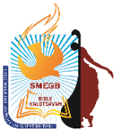 | 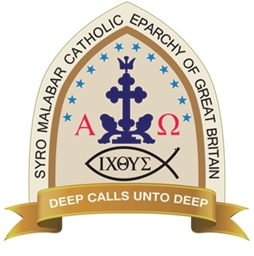  Syro Malabar Eparchy of Great Britain  1st SMEGB Bible Kalotsavam 2017 www.smegbbiblekalotsavam.com
Saturday, 4th November 2017
Registration Form for Individual items
Registration closes on 22/10/2017. Please email the completed form.

Registration process
All winner of regional competitions (individual items 1st, 2nd,3rd & 1st in group item) should complete through their regional coordinators or directly by completing the form and emailing to registration@smegbbiblekalotsavam.com
This should be received by 22/10/17 along with your payment to us as below.
A/c Name : CDSMCC A/c no: 89082265, Sort code : 52 10 03, Ref : Your name, Region
For venue details, schedule & rules please refer to flyers or website. If you have any queries while completing this form please contact us on 07734303945
or email us: info@smegbbiblekalotsavam.com
* Mandatory fields
Full Name*
(As it should appear in the certificate)
Age*:  (as on 31/8/17) | yrs | Current School Year :
Address*
E-mail*
Phone number* | Mobile:  Landline:
I would prefer to be contacted by? | Text/ Mobile/ Landline/Email  (delete as appropriate)
Community/ Mass centre*
Region
Items participating in*  Position in Regional Kalotsavam | - Position :  - Position :  - Position :  (Not more than 3 items per participant.)
Queries/Requests | (Please include any questions/special requests that you may have here and we will get back to you as soon as possible)

(All details in this registration form will be kept strictly confidential and only seen by the SMEGB team. Children below 18 yrs require parental consent prior to returning the registration form. All young children must be accompanied by an adult for the event)
Thank you for completing the form. The SMEGM team will be contacting you after 22/10/2017.

