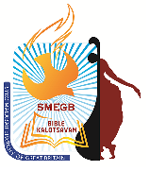 | Catholic Syro Malabar Eparchy of Great Britain  Bishop’s Office, St. Alphonsa of Immaculate Conception Cathedral,  St. Ignatius Square, Preston, Lancashire, UK PR1 1TT www.smegbbiblekalotsavam.com  Bible Apostolate | 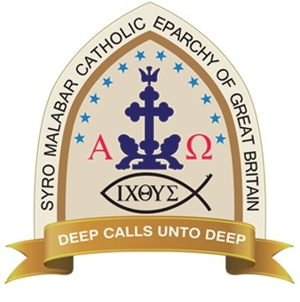

Regional Registration Form for Individual items: Bristol – Cardiff
Registration closes on 6/10/2019. Please email the completed form.

For venue details, schedule & rules please refer to flyers or website. If you have any queries while completing this form please contact Roy Sebastian 07862701046 smbcr@smegbbiblekalotsavam.com * Mandatory fields

Full Name*
(as to appear in certificate)
Age* (as on 31/08/19) | yrs | Current School Year
Address & Postcode*
Parish/Mission centre *
E-mail*
Phone number(s)*
Items participating in* | (Not more than 3 items per participant. Should your item of choice clash with another schedule you will be notified by SMM team)
Preferable Contact | Text/ Phone/Email (delete as appropriate)

(All details in this registration form will be kept strictly confidential and only seen by the Kalotsavam team. Kalotsavam team is committed to processing information in accordance with the General Data Protection Regulation (GDPR). The personal data collected on this form will be held securely and will only be used for administrative purposes.Children below 18 years require parental consent prior to returning the registration form. All young children must be accompanied by an adult for the event)
Please indicate whether you have given parental consent in each case by ticking the box and sign and date the form (to comply with General Data Protection Regulation/Data Protection Act 2018).
☐ I give my permission for my child to attend Bible Kalotsavam and its activities organised by the Catholic Syro-Malabar Eparchy of Great Britain.
☐ I understand that personal data given in this form will be processed by the Catholic Eparchy of GB.
☐ I consent to the use of information and images (including photographs and video recordings as part of the event to be used in church and Eparchy website, publications, wall and classroom displays, presentations, churches, social media, local newspaper and it could appear in the public domain.
☐ I give my permission for the Eparchy to contact me via □ post □ phone or □ email to circulate news, events, activities and services of the Catholic Syro-Malabar Eparchy of Great Britain.
If you change your mind at any time, you can let us know by emailing the respective Bible Kalotsavam Regional co-ordinators.
Declaration: I hereby agree to adhere to the guidelines and regulations of Catholic Syro-Malabar Eparchy of GB.

Parent’s Name*: Signature*: Date*:

CATHOLIC SYRO-MALABAR EPARCHY OF GREAT BRITAIN complies with its obligations under GDPR/DPA 2018 by processing data lawfully; keeping personal data up to date; by storing and destroying it securely; by not collecting or retaining excessive amounts of data; by protecting personal data from loss, misuse, unauthorised access and disclosure and by ensuring that appropriate technical measures are in place to protect personal data. For more information on how we use your data, please read our ‘Privacy Notice’ which can be accessed on our website.

Thank you. The SMBCR Kalotsavam team will be contacting you after 6/10/2019.

